**System User Interface- Quest Screens.**

The quests screens are navigated to from the bottom Menu whilst in the Main Base or on the World Map. Here are all the running statistics for your gameplay and the rewards for reaching certain milestones.

In the excel datasheet, all the ‘quest points’ are listed. Regardless of what value any tied-in variables reach, the quest screen will never go beyond any quest point that has not been collected. For example, the ‘total resources produced’ variable (VS_QRP_F01) may reach, say, 10 million food produced, but if the player has not ‘collected’ the first quest, that quest remains on screen and any rank does not level up until the player collects it. In this case, the player may sit and collect the same quest for a while until the quests catch up to the value of the variable.

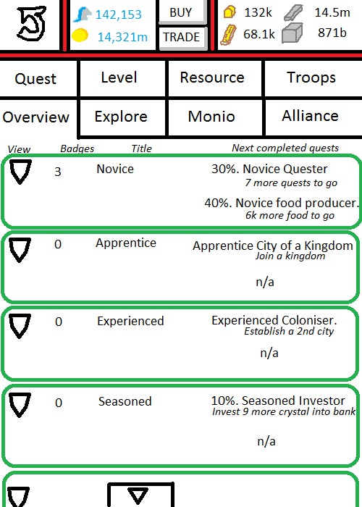

Above is the ‘main screen’ of the quests menu. Notice the sub-menu ‘Overview’ is open. This is the default screen open when navigating to the quests menu.

The overview page gives a convenient snapshot of where a player is at with regards to completed quests. Furthermore, the next completed quests are shown next to each title. These will show how much work is required to complete the next closest quest. Consequently, if a quest is complete, this overview screen will allow you to collect your reward for that quest, and then update to show the next closest quest.

The top of the screen shows the menu accessible in every module- the ‘back’ button to return to the Main Base, the crystal and gold menu, and your resource menu.

Below this are the various quest menus. Touching any will take you to the applicable screen to give you more detailed, and full information, on all the quests that can be completed in that category.

Below the quest menus is the currently selected menu. In this case, the overview.   
To the left, you have your rank badge. This will be colourful if you have completed any of the applicable quests and have achieved a rank badge, or it will be greyed out if no quests have been completed of that rank yet. You can touch the medal to view a list of all the quests completed that have given you a badge for that rank.  
Next to this is a number of the badges you’ve achieved for this rank.  
Near the middle, we have the title of all the quests. The first is novice, the panel beneath would be apprentice, and it progresses.   
On the right, we have the next closest to completing quests for that rank. If it is a quantifiable quest, for example, produce 100k food, then a percentage completed will appear and an indication of how much more food you need to produce to complete the quest. If it is unquantifiable, such as joining a Kingdom, it will simply show you what you need to do to complete the quest.

**User Interface (Quest screen).**

Standard top menu (back button, crystal/gold menu, and resource menu).

Quest Menu. Clicking on any of the 8 categories takes you to the corresponding screen.

Badges. Each badge opens a corresponding screen that lists all the quests completed that achieved on of those badges.

Scroll Menu. No Buttons- swiping up or swiping down will scroll the overview screen up and down to reveal all the quest overviews.

**Graphics in Use.**

GIMB_046. Quest Icon. The icon on the main menu you press to get to quest screens.  
GIA_004. Greyed Badge Icon. A greyed out badge that denotes you have not completed any quests yet for that rank.  
GIA_005. Novice Badge.  
GIA_006. Apprentice Badge.  
GIA_007. Experienced Badge.  
GIA_008. Seasoned Badge.  
GIA_009. Expert Badge.  
GIA_010. Master Badge.  
GIA_011. Grandmaster Badge.  
Various icons for the items shown as rewards.

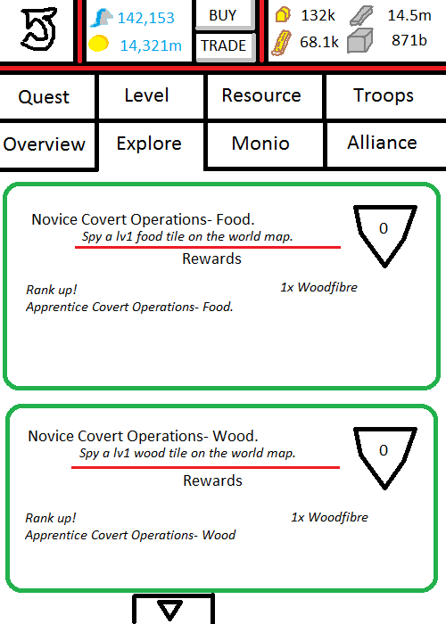

Above is a poorly created picture that shows one of the quest screens- namely, the ‘explore’ screen. Here it will list the actual quests in this category. There is far more detail here than in the overview screen.

Each quest will note:  
The current quest title (Novice Covert Operations- Food).  
What needs to be achieved to level up (Spy a lv1 food tile on the world map). If this is quantifiable, it will also give a percentage of how much is completed, and a figure of how much more needs to be created/collected.  
A bigger rank badge to the right with the current ‘level’ progression overlaid.  
The rewards. If a rank up occurs, this will be listed. Any items or gold gained, will be listed.

**Total menu list.**

Refer to the ‘Quest Log’ excel spreadsheet for all stats, rewards, and variables.

Quest.   
Quest points QQ_01- QQ_20. Quest name: Novice- Grandmaster Quester.  
*Variable VS_QQ_01. All quests claimed increase this variable by a value of 1.*

Level.  
Quest Points QL_01-QL_12. Quest Name: Novice-Grandmaster Duke/Duchess.  
*No variable. Quest points achieved off the back of player level.*

Resource.  
Quest Points QRP_01-QRP_18. Quest name: Novice-Grandmaster Food Producer.  
*Variable VS_QRP_F01. All food ever produced is deposited in this variable.*  
Quest Points QRP_19-QRP_36. Quest Name: Novice-Grandmaster Wood Producer.  
*Variable VS_QRP_W01. All wood ever produced is deposited in this variable.*  
Quest Points QRP_37-QRP_54. Quest Name: Novice-Grandmaster Metal Producer.  
*Variable VS_QRP_M01. All metal ever produced is deposited in this variable.*  
Quest Points QRP_55-QRP_72. Quest Name: Novice-Grandmaster Stone Producer.  
*Variable VS_QRP_S01. All stone ever produced is deposited in this variable.*  
Quest Points QRE_01-QRE_10. Quest name: Novice-Grandmaster Food Entrepreneur.  
Quest Points QRE_11-QRE_20. Quest Name: Novice-Grandmaster Wood Entrepreneur.  
Quest Points QRE_21-QRE_30. Quest Name: Novice-Grandmaster Metal Entrepreneur.  
Quest Points QRE_31-QRE_40. Quest Name: Novice-Grandmaster Stone Entrepreneur.  
*No variables for these four (QRE) as quest points are achieved via the total resources being produced at any one time.*

Troops.  
Quest points QT_01-QT_17. Quest name: Novice-Grandmaster Basic Barracksmaster.  
*Variable VS_QT_B01. All basic troops of any type that are PRODUCED (not purchased) are deposited into this variable.*Quest Points QT_18-QT_34. Quest name: Novice-Grandmaster Advanced Barracksmaster.  
*Variable VS_QT_C01. All core troops of any type that are PRODUCED (not purchased) are deposited into this variable.*Quest Points QT_35-QT_51. Quest Name: Novice-Grandmaster Elite Barracksmaster.  
*Variable VS_QT_E01. All elite troops of any type that are PRODUCED (not purchased) are deposited into this variable.*

Explore.  
QE_01-QE_05. Novice-Grandmaster Covert Operations- Food.  
QE_06-QE_10. Novice-Grandmaster Covert Operations- Wood.  
QE_11-QE_15. Novice-Grandmaster Covert Operations- Metal.  
QE_16-QE_20. Novice-Grandmaster Covert Operations- Stone.  
QE_21-QE_25. Novice-Grandmaster Land Conqueror- Food.  
QE_26-QE_30. Novice-Grandmaster Land Conqueror- Wood.  
QE_31-QE_35. Novice-Grandmaster Land Conqueror- Metal.  
QE_36-QE_40. Novice-Grandmaster Land Conqueror- Stone.  
*No variables required- a single spy or conquer fulfils the quest.*  
QE_40-QE_49. Novice-Grandmaster Farmer of Kingdoms.  
*VS_QE_FOK1. All resources ever obtained from farming a base or a march are deposited in this variable (nothing is subtracted for intercepted goods).*

Monio.  
QC_01-QC_04. Novice- Grandmaster Monio Owner.  
*VS_QC_MU1. Any new unique Monio caught, collected, or obtained from an item increases this variable by 1. Other variables and dependencies exist to correctly use this variable.*  
QC_05-QC15. Novice-Grandmaster Team Completionist.  
*VS_QC_TC1. Any new element team completed that has not been registered already increases this variable by 1.*  
QC_16-QC_31. Novice-Grandmaster Monio Trainer.  
*No variable required. When any Monio reaches a level coinciding with a new quest point, that quest point is achieved.*QC_32-QC_37. Novice-Grandmaster Monio Battler.  
*VS_QC_MB1. All battles increase this variable by 1 (win or loss).*  
QC_38-QC_43. Novice-Grandmaster Battle Perfectionist.  
*VS_QC_MB2. Win-streak variable. This variable is increased by 1 for every successful battle and wiped to 0 for every loss.*

Alliance.  
QK_01-QK_04. Novice-Grandmaster City of a Kingdom.  
*VS_QK_KD1. Variable increases by 1 for every day in a Kingdom.*QK_05-QK_08. Novice- Grandmaster Investor.  
*VS_QK_CV1. Variable increases by any crystal donated to Kingdom funds.*QK_09-QK_16. Novice-Grandmaster Banker.  
*VS_QK_BK1. Variable increases by all resource amounts that are successfully delivered to a bank (not intercepted, or recalled).*QK_17-QK_21. Novice- Grandmaster Coloniser.  
*No variable.*